Setting Up an Appointment Campaign
Appointment Campaigns enable the advisor to request that specific students select a specific date and time within a specified period to schedule an appointment instead of the advisor creating appointments for each and every student. This feature is commonly used when an advisor must meet with all of their students during the semester (e.g. during the advising period.)

STEP 1: Your first step is to set up your Availability for the Appointment Campaign.
Click on the My Availability tab on your Staff Home page and select Add Time:
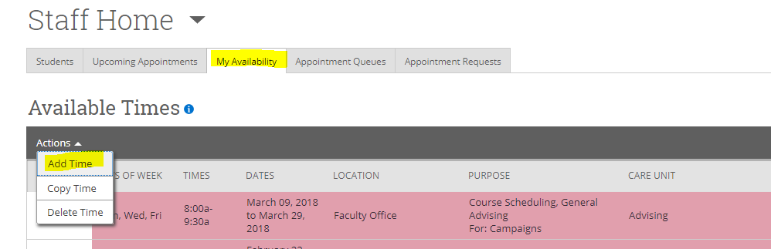

Step 1: Select the days and times when you are available to meet with students
Step 2: Select the Duration (e.g. advising period)
Step 3: Select Campaigns.
Step 4: Select Advising under Care Unit
Step 5: Select the Location (e.g. Faculty Office for faculty appointments)
Step 6: Lastly, select which student services you can provide to students during this availability. You may select one or more, but you must select at least one.
Step 7: Use the optional Special Instructions area to add any comments, such as your office location
Step 8: Click the Save button.

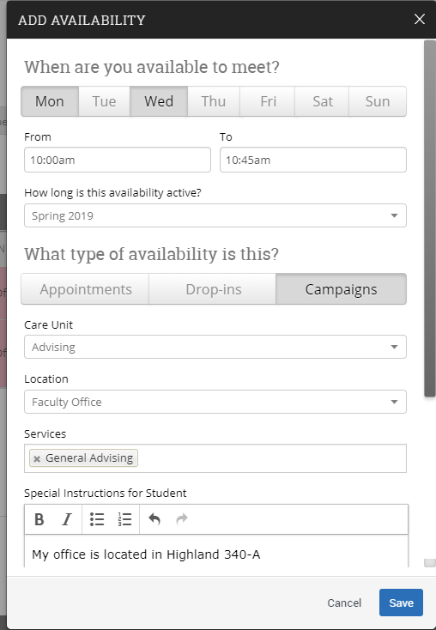Add Time-

Repeat this process until all of your availabilities have been defined.
Note: You can have as much availability as needed.
There are two other options when adding Times Available.
Copy Time - to copy a time, select the time you would like to copy and then click the Copy Time button. The availabilities will be copied and a dialog will open allowing you to make edits or to save your newly created availability.
Delete Time- to delete your time, simply select the time and click the Delete Time button.

IMPORTANT: If you want to add this availability to your Outlook calendar, in order to hold it until students make appointments, you must create these Outlook events as Free. Otherwise, these Outlooks events will feed over to your SSC calendar and make you unavailable for student appointments.

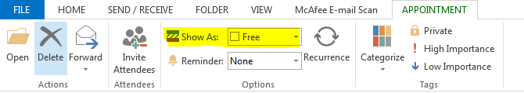

Also, do not duplicate your availability on your SSC calendar (for example, by creating general events that mimic these time slots.) This will tell the system that you are no longer available at these times.
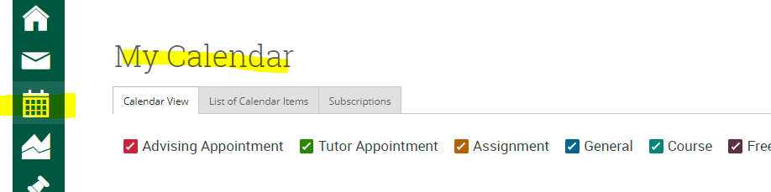

STEP 2: Set up your Appointment Campaign
To begin, click on Campaigns in the left hand navigation menu
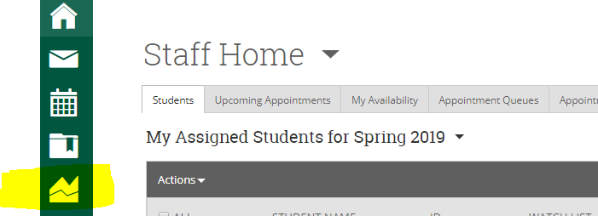

or click on Appointment Campaigns from the right hand Quick Links:
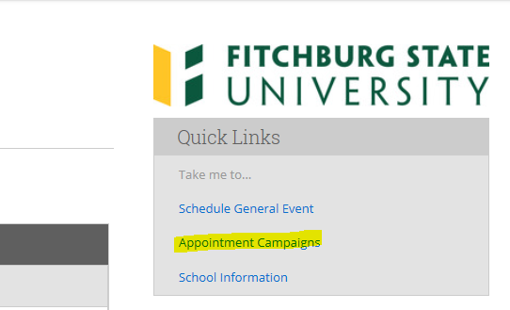

Then click Appointment Campaigns again in the right hand Actions Menu.

You will then be walked through the steps for setting up your Appointment Campaign.

Step 1: Define the Campaign

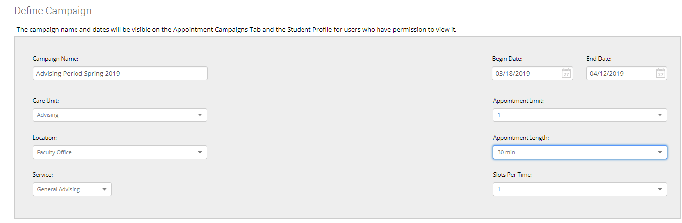

Campaign Name -The name of the campaign only appears to the advisor. This needs to be a name that makes sense to you.
Care Unit- Select Advising
Location – faculty should select Faculty Office.
Service- Select the reason for the appointment, such as General Advising or Course Scheduling. Important: The Reason(s) listed here must match the Services that you set up for your Availability (see above.)
Choose the Begin and End Dates- This will be the date range for which you want the students to make their appointments. For example, the fall 2017 advising period is 10/11/17 – 10/27/17.
Appointment Limit- This will determine how many appointments you wish for the student to schedule for this campaign (e.g. advising period.)
Appointment Length- This is where you define how long the appointment will be.
Slots Per Time: This determines how many students can be scheduled during each slot (i.e. more than one student would be meeting with you at the same time)

Select Continue

Step 2: Add Students to Campaign
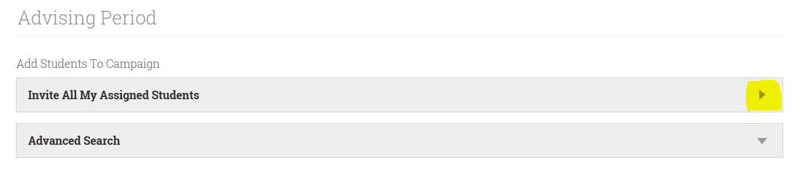
Invite All My Assigned Students: Provides you with all students that are assigned to you (i.e. all of your advisees.) Faculty will typically use this option.
Advanced Search: Provides you with advanced search filters to find, and select, students from your advisee population. For staff without assigned advisees, you would use this option to select your students and to access a preloaded Watch List.
Once you have selected your students, you will be able to review the student list and remove any students that you wish to exclude.

Select Continue

Step 3: Add Advisors to Campaign- You will need to select yourself as the advisor for the campaign.

Select Continue

Step 4: Compose your Message- Compose the message that you will send to students.
Email Subject: The topic will be the subject of the email going to the student.
Instructions or Notes: This will be your message to the student. Include your office location here.
Note: This screen will also give you a preview of what the invite will look like.

Select Continue
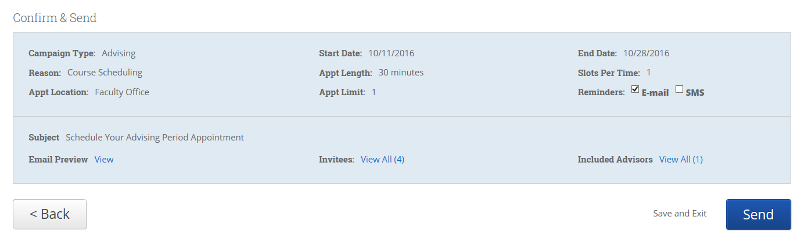
Step 5: Confirm and Send- Please make sure that you review your selected options before you start the campaign. Click Send when you are ready to email the invites to the selected students.
You may also Save and Exit, which allows you to defer sending the campaign until you are ready. If you Save and Exit, you may edit the campaign at any time, prior to sending it.

