Issuing an Alert in SSC
An Alert is comparable to a referral. When you issue an Alert in SSC, you are notifying another office that a student may need assistance. An email is also sent to the student and in most cases, to his or her advisor. Issuing an alert also opens a Case which must be closed by the receiving office. Once the Case is closed, you will receive notification.
To issue an Alert, simply click the Issue an Alert button from the right side menu and then select an Alert Reason. Current options are Academic Coach Referral, Tutor Referral, Attendance Issue and Financial Aid Referral:
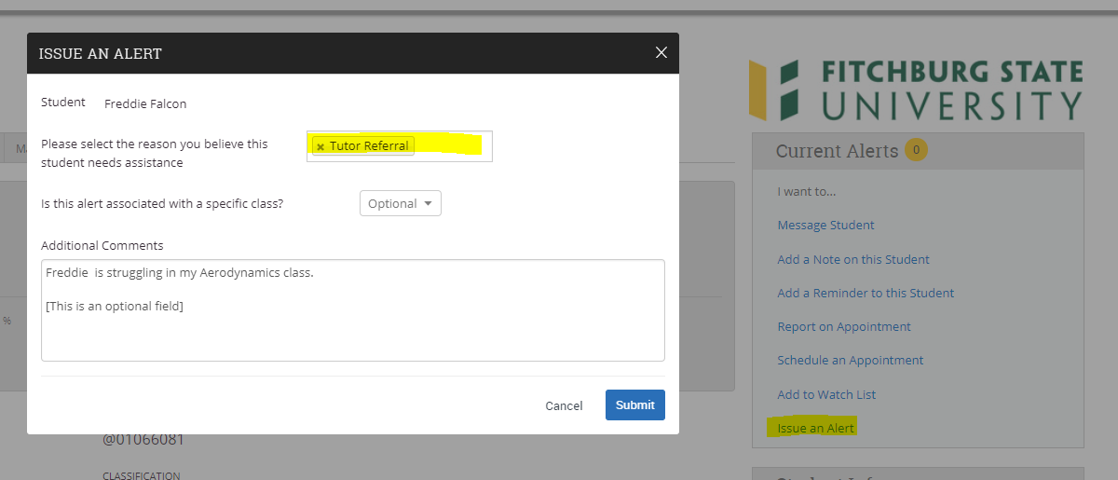
Optional fields allow you to select a course or add a comment.
Once an Alert is issued and a Case is opened, you will see a notice in the upper right corner. This includes Alerts and Cases issued by other staff and faculty:
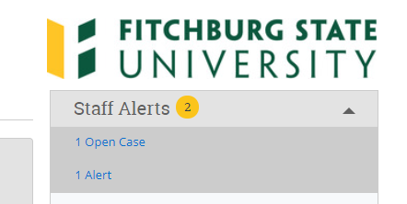
You can click on either to view the details. You can also see Alerts and Cases on the student’s History tab:
