Pulling Incomplete Grades in SSC
Begin by executing a Search and clicking the Show Advanced Filters box:
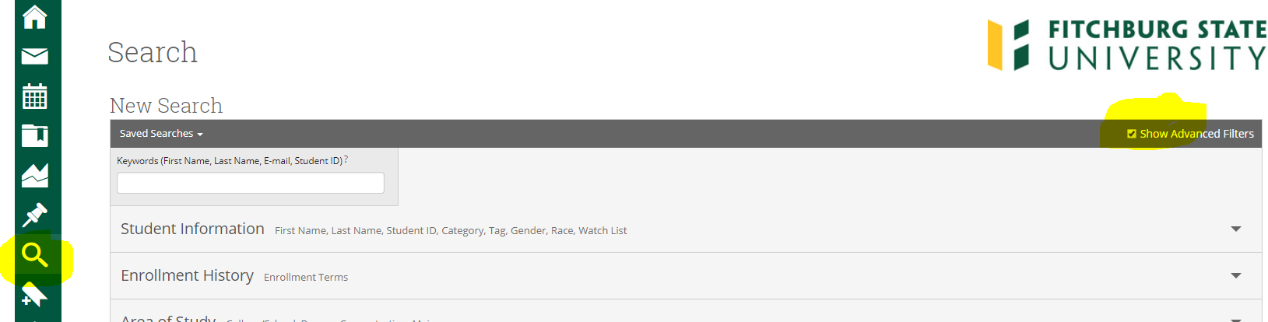
Expand the Course Data filter and select the Term, Course and Section of the course you are querying. Then select Final Grade Received and select the grade of IN:
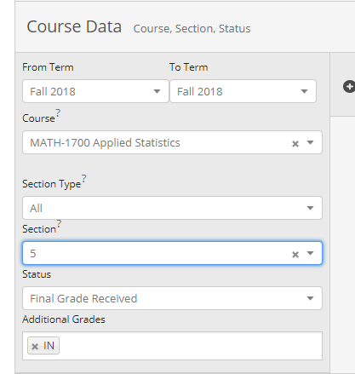
Select Search to execute your query. You will need to run this for each of your courses.

