Setting Up Office Hours For the Semester in SSC
Office hours can be set up in two ways:
- Option 1: Display your open office hours and do not allow students to make appointments during your office hours.

- Option 2: Allow students to make appointments during your office hours.

Option 1: Display your open office hours and do not allow students to make appointments:
Set Up Your Availability:
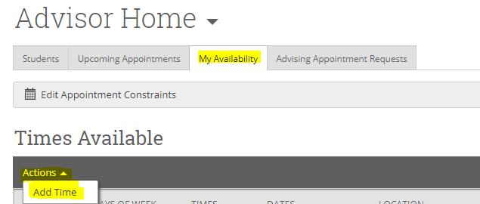
Add Time-
Step 1: Select the day(s) and time of your office hours.
Step 2: Select Drop-Ins.
Step 3: Select the duration (e.g. Fall 2017)
Step 4: Choose the location where you will be available (e.g. Faculty Office.)
Step 5: Select which student services you can provide to students during this availability. You may choose multiple options, but you must select at least one.
Step 6: Add any important information under Details, such as your office location. You may also note changes in open office hours that may occur during Advising Period. (See below)
Step 7: Click the Save button.
Repeat this process until all of your availabilities have been defined.
Note: You can have as much availability as needed.

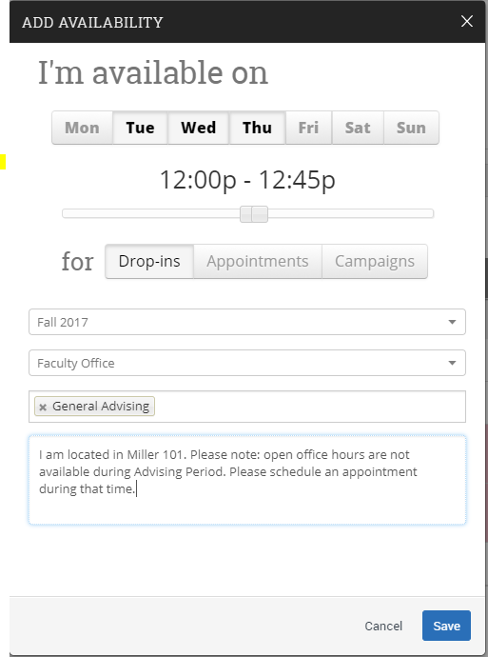

Student View:
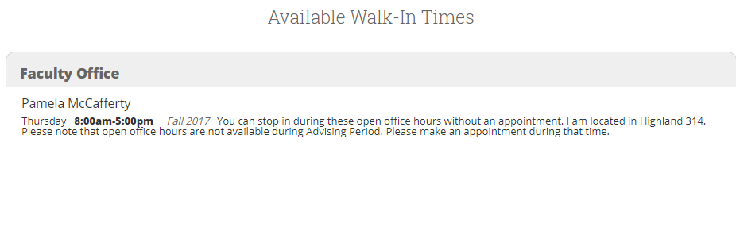

Notes:
Availability set up as Drop-In serves to provide a viewable message to students. It does not, however, hold any of your time within SSC. In other words, students will be able to view your drop-in hours but these hours will not be reserved in any way in SSC. If you choose to put a hold on these hours, you have two options:
Option 1: If you sync SSC to your external calendar (e.g. Outlook and gmail) and you set up your office hours as Busy in your external calendar, these will feed into your SSC calendar as Busy.
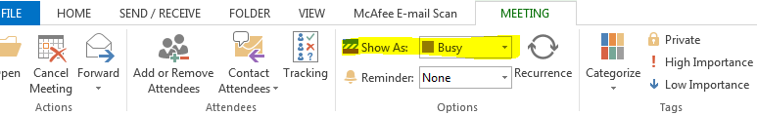

Option 2: If you prefer to set up your office hours within the SSC calendar (e.g. you do not sync to an external calendar) you can add them as General Event(s):
From your SSC Calendar, select Add Calendar Event:
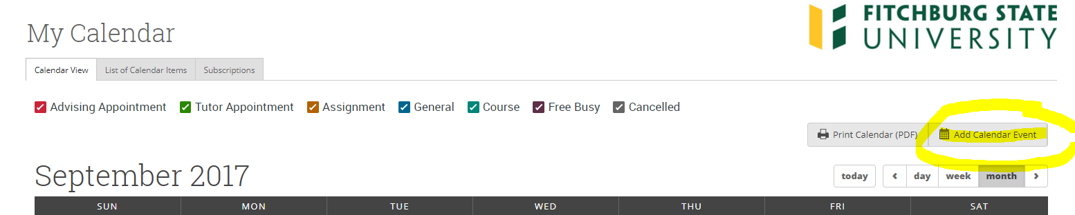

On the left side, set up as follows and then select one day of the week for your office hours:
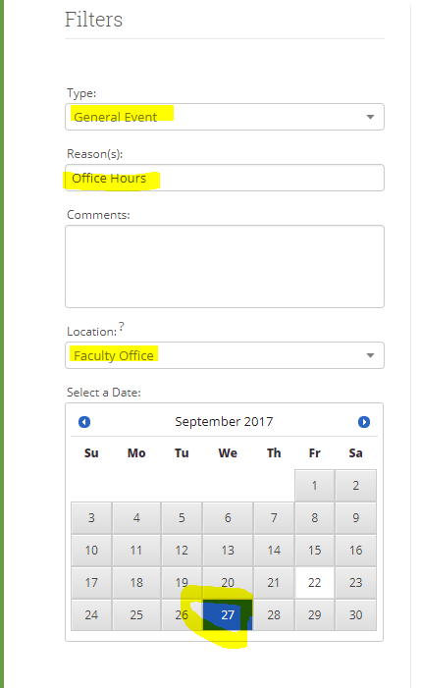
On the right side, set a time increment and a time block:
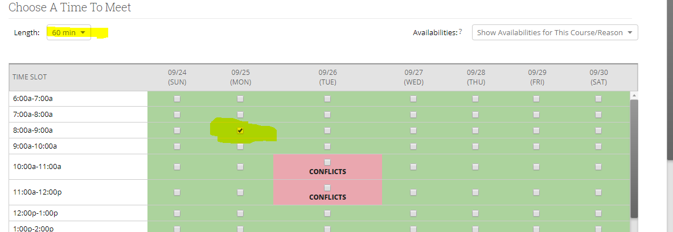
Then set up how this will repeat and Save:

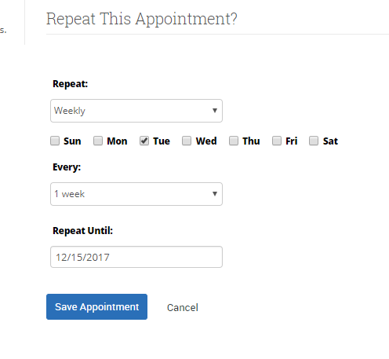
This will then feed into your SSC calendar as a repeating appointment. You can repeat this process for other days/times of the week (if you cannot accommodate it through the Repeat functionality.)
It should display similar to this:
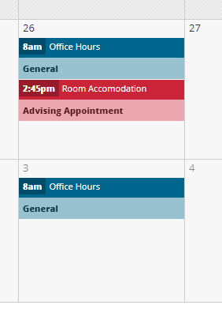

Option 2: Allow students to make appointments during your office hours:
Click on the My Availability tab on your Advisor Home page and select Add Time:
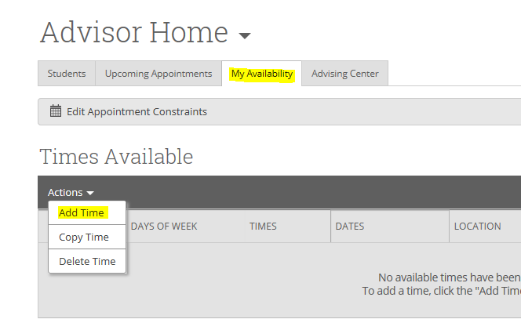

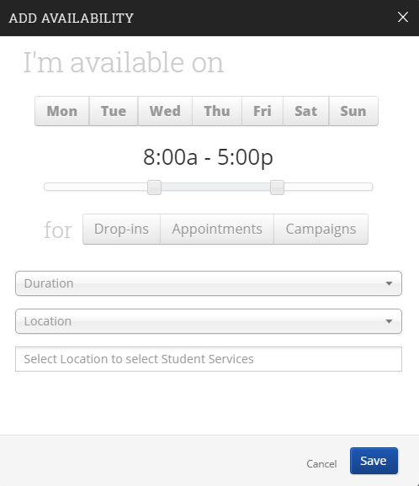
Add Time-
Step 1: Select the days and time when you are available to meet with students.
Step 2: Select Appointments
Step 3: Select the duration (e.g. Fall 2017)
Step 4: Select the location (e.g. Faculty Office.)
Step 5: Select which student services you can provide to students during this availability. You may select multiple options, but you must select at least one.
Step 6: Add Details, such as your office location.
Step 7: Click the Save button.

Repeat this process until all of your availabilities have been defined.

Note: You can have as much availability as needed.
IMPORTANT: If you want to add this availability to your Outlook calendar, in order to hold it until students make appointments, you must create these Outlook events as Free. Otherwise, these Outlook events will feed over to your SSC calendar and make you unavailable for student appointments.

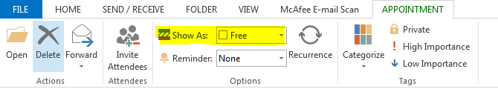

Also, do not duplicate your availability on your SSC calendar (for example, by creating general events that mimic these time slots.) This will tell the system that you are no longer available at these times.
QUESTIONS? Contact ssc@fitchburgstate.edu

