Searching for Students in SSC
Simply click on the Quick Search icon in the upper right hand corner and type in either name or ID:
You may also search for a student using the Search icon located in the left-hand navigation menu:
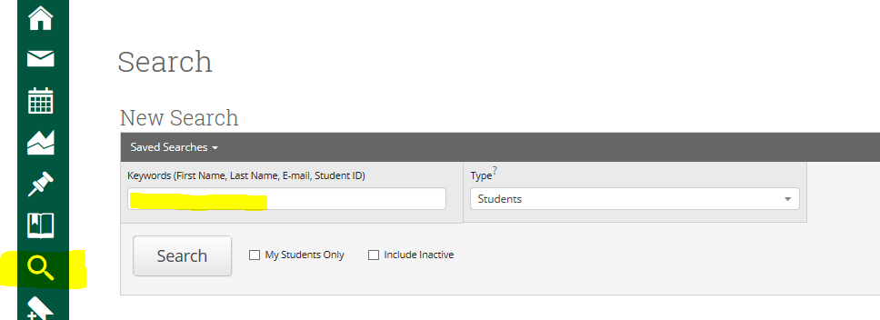

To search for a group of students, such as all students in a major, click on the Show Advanced Filters box in the upper right hand corner:
