Dear Colleagues,

Recently I notified the campus community that beginning this fall, the University will commence the process of writing a self-study report in preparation for our 10-year comprehensive regional accreditation review by the New England Commission of Higher Education (NECHE).

To remain accredited, our institution must undergo a process of self-review where we assess ourselves and our mission relative to NECHE’s nine standards. This process provides a framework for institutional development and self-evaluation. The process is meant to foster improvement and assure quality.

The self-study report will be written through committees structured around the standards. The committees will be formed as outlined below. NECHE’s accreditation standards descriptions can be found at https://www.neche.org/resources/standards-for-accreditation/. The MSCA is in the process of seeking faculty volunteers for these committees as well.

• Standard Committees One, Two, Three:
- Standard One: Mission and Purpose
- Standard Two: Planning and Evaluation
- Standard Three: Organization and Governance
• Standard Four Committee: The Academic Program
• Standard Five Committee: Students
• Standard Six Committee: Teaching, Learning, and Scholarship
• Standard Seven Committee: Institutional Resources
• Standard Eight Committee: Educational Effectiveness
• Standard Nine Committee: Integrity, Transparency, and Public Disclosure

Members of these committees will work over the fall and spring semesters to provide a draft report by the end of the spring 2021 semester. To be able to articulate how the university adheres to these standards, we need broad representation from across campus. We understand that some of you are just finishing up your work on strategic planning committees but we are hopeful that many of you will step forward to join this vitally important work. We only do a comprehensive self-study once every 10 years.

Getting involved in the university’s preparation for accreditation review may be one of the most important service activities you can provide the institution. If you are interested in serving on a committee, we ask that you respond by emailing NECHE2022@fitchburgstate.edu no later than Monday, June 1st. We will finalize committees over the summer so that we are able to begin the work early in the fall semester.

We look forward to our collective work as we prepare for our NECHE accreditation review.

Sincerely,

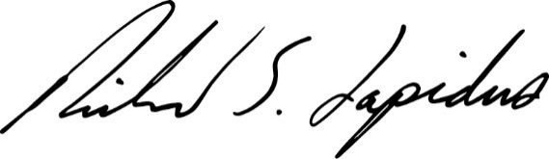
Richard S. Lapidus
President

