Setting Up Your Availability
As a new user, the first thing you need to do is set up availability in order to schedule appointments.
Click on the My Availability tab on your Advisor Home page and select Add Time:
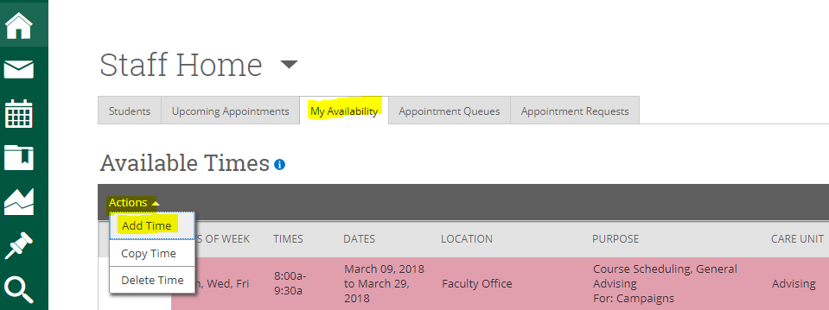
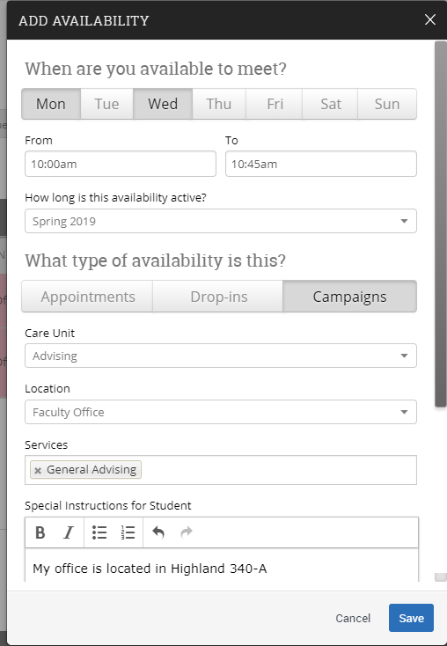
Step 1: Select the days and times when you are available to meet with students
Step 2: Select the Duration (e.g. advising period)
Step 3: Select Campaigns.
Step 4: Select Advising under Care Unit
Step 5: Select the Location (e.g. Faculty Office for faculty appointments)
Step 6: Lastly, select which student services you can provide to students during this availability. You may select one or more, but you must select at least one.
Step 7: Use the optional Special Instructions area to add any comments, such as your office location
Step 8: Click the Save button.

Repeat this process until all of your availabilities have been defined.
Note: You can have as much availability as needed.
There are two other options when adding Times Available.
Copy Time - to copy a time, select the time you would like to copy and then click the Copy Time button. The availabilities will be copied and a dialog will open allowing you to make edits or to save your newly created availability.
Delete Time- to delete your time, simply select the time and click the Delete Time button.

IMPORTANT: If you want to add this availability to your Google calendar, in order to hold it until students make appointments, you must create these events as Free. Otherwise, these events will feed over to your SSC calendar and make you unavailable for student appointments.
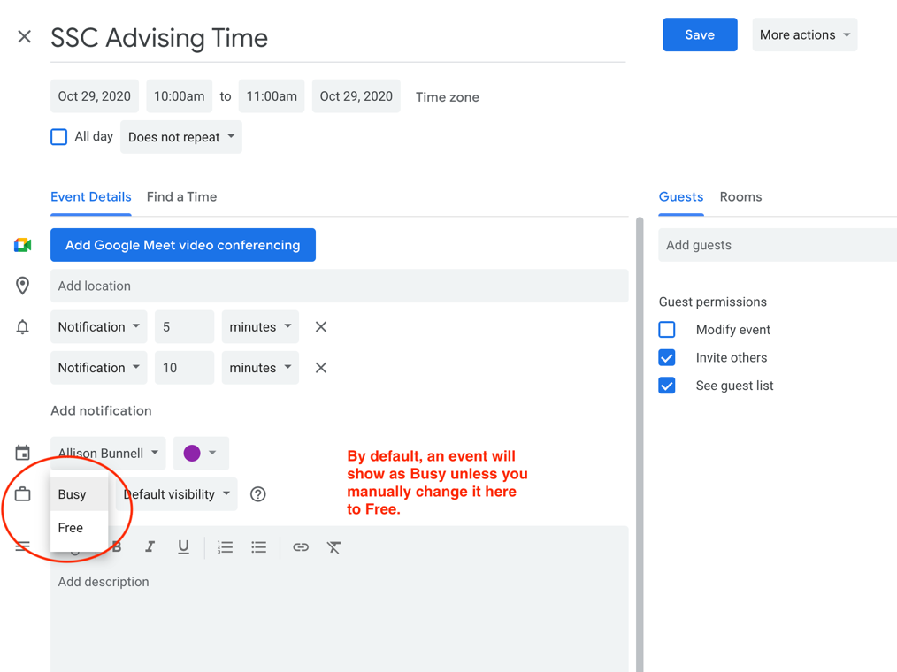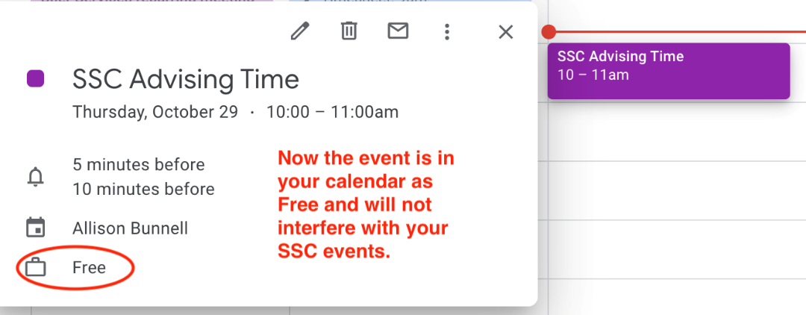
Also, do not duplicate your availability on your SSC calendar (for example, by creating general events that mimic these time slots.) This will tell the system that you are no longer available at these times.
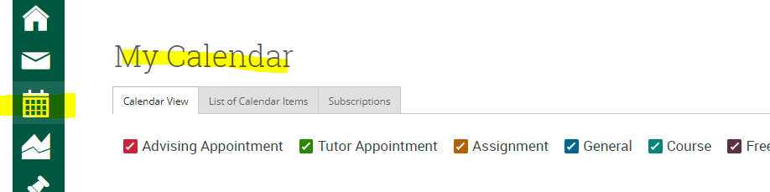

Questions? Contact ssc@fitchburgstate.edu
Setting Up Your Availability for an Appointment Campaign, such as for the Advising Period:
For the Advising Period, you will want to set up availability under Campaigns.
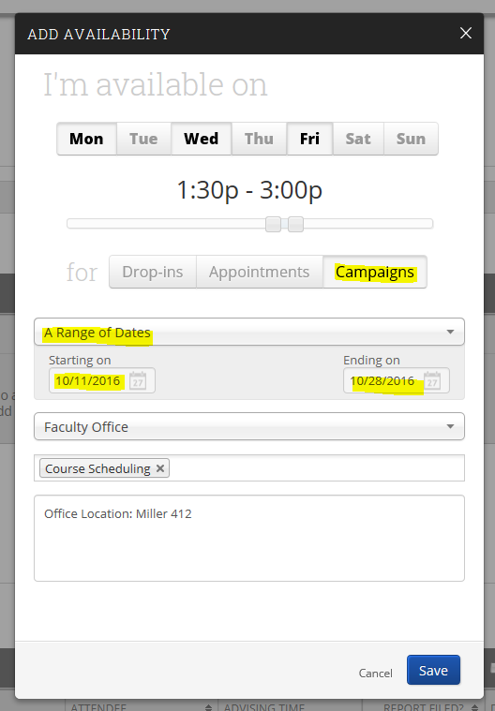
This will then be the availability sent to students via the Appointment Campaign. See the Setting up an Appointment Campaign document.
Note: You can have as much availability as needed (i.e. you can set up multiple availabilities under Campaigns and tie them all to your Appointment Campaign.

To edit your availability, simply click on the Edit link on the right:
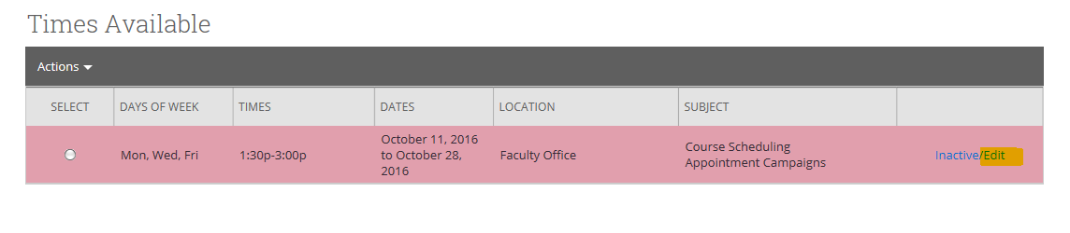
IMPORTANT: If you want to add this availability to your Google calendar, in order to hold it until students make appointments, you must create these events as Free.
Otherwise, these events will feed over to your SSC calendar and make you unavailable for student appointments.

Also, do not duplicate your availability on your SSC calendar (for example, by creating general events that mimic these time slots.) This will tell the system that you are no longer available at these times.

Questions? Contact ssc@fitchburgstate.edu

