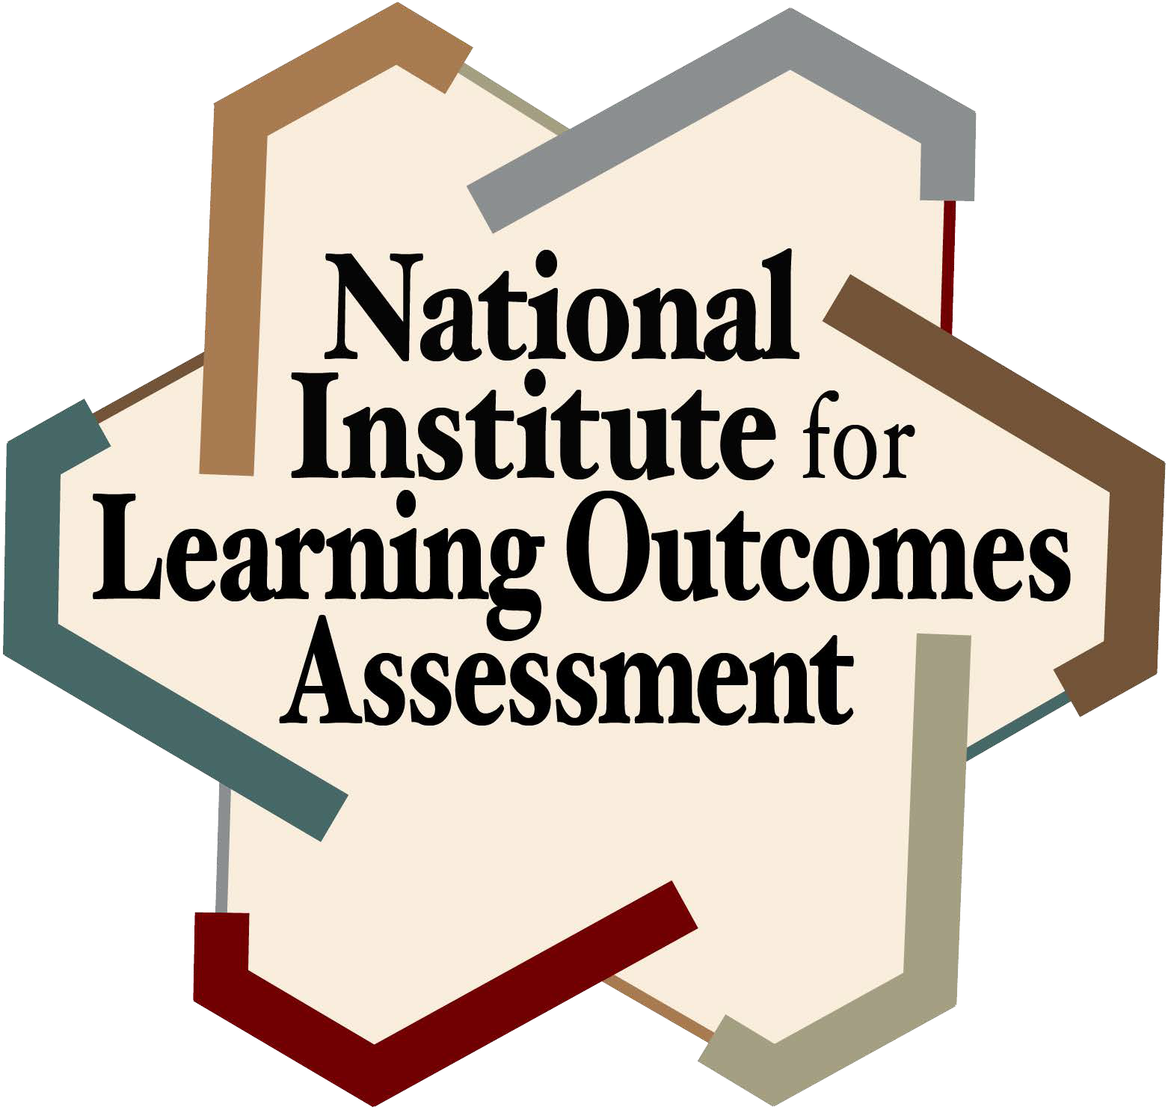

Assignment Discussion
Fitchburg State University

- What learning outcomes are being assessed in the assignment?

- What learning outcomes are you asking them to demonstrate in the completion of the assignment?

- How clear is that to the students? How could it be presented in a more culturally responsive manner?

- Does the criteria used to evaluate the assignment align with the learning outcomes being assessed?

National Institute for Learning Outcomes Assessment (NILOA) 51 Gerty Drive
Suite 196 CRC, MC-672
Champaign, IL 61820 niloa@education.illinois.edu www.learningoutcomesassessment.org

